What works:

* All of part 1 (material properties, shading types)
* All of part 3 (Spotlight, keyboard commands)

What doesn’t:

* The attenuation factor is calculated and multiplied in. It works for the diffuse and specular components, but does not change the ambient components of the light

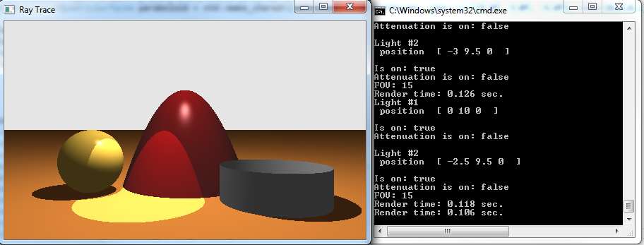Scene with both lights on

Scene with only spotlight, position and FOV changed using keyboard commands

